DATE- 01-09-2022

K.C.RAJATH KUMAR(19211052)

1. WAP in C++ to check whether the given no. is palindrome or not

PROGRAM-

#include <iostream>

using namespace std;

int main()

{

int a,n,s,rev=0;

cout<<"enter the value:";

cin>>a;

n=a;

while(a!=0)

{

s=a%10;

rev=(rev*10)+s;

a=a/10;

}

cout<<"reverse of the number is"<<rev<<endl;

if(n==rev)

{

cout<<"the number is palindome";

}

else

{

cout<<"the number is not palindrome";

}

return 0;

}

OUTPUT-

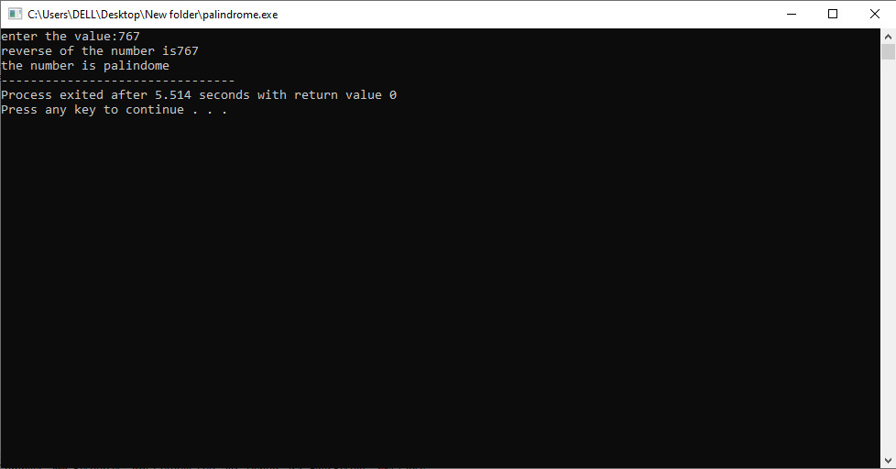

1. WAP in C++ to check whether given no. is Armstrong number or not?

PROGRAM-

#include <iostream>

using namespace std;

int main()

{

int a,n,rem,res=0;

cout<<"enter the value:";

cin>>a;

n=a;

while(n!=0)

{

rem=n%10;

res+=rem*rem*rem;

n/=10;

}

if(res==a)

{

cout<<a<<"is an armstrong number";

}

else

{

cout<<a<<"is not an armstrong number";

}

return 0;

}

OUTPUT-

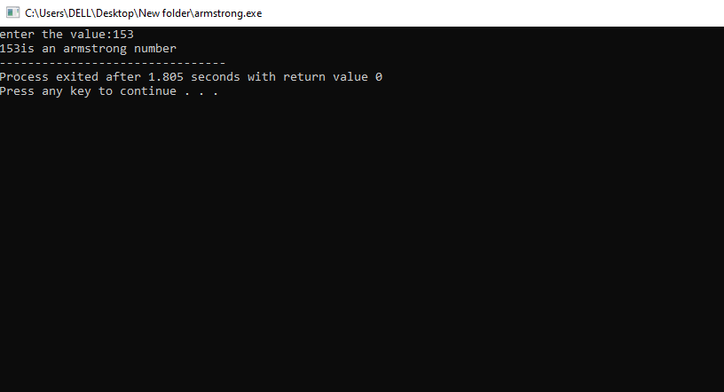

1. WAP in C++ to print the factorial of a given number

PROGRAM-

#include <iostream>

using namespace std;

int main()

{

int i,n,fact=1;

cout<<"enter the no.";

cin>>n;

for(i=1;i<=n;i++)

{

fact=fact*i;

}

cout<<"factorial of the given no is"<<fact;

return 0;

}

OUTPUT-

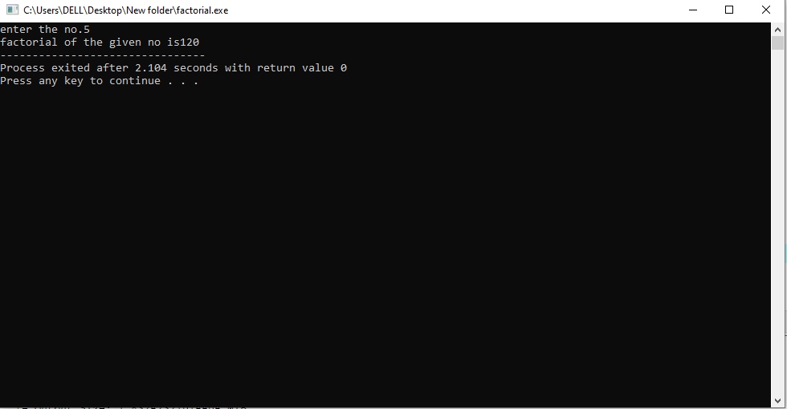

1. WAP in C++ to print the Fibonacci series of given no. of terms

PROGRAM-

#include<iostream>

using namespace std;

int main()

{

int n,i,a=0,b=1,c=0;

cout<<"enter the no. of terms:";

cin>>n;

cout<<"fibonacci series:";

for(i=1;i<=n;++i)

{

if(i==1)

{

cout<<a<<", ";

continue;

}

if(i==2)

{

cout<<b<<", ";

continue;

}

c=a+b;

a=b;

b=c;

cout<<c<<", ";

}

return 0;

}

OUTPUT-

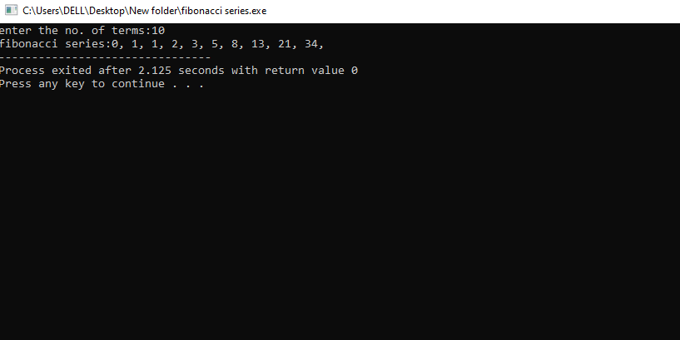

1. WAP in C++ to print the marksheet of a student

PROGRAM-

#include <iostream>

using namespace std;

int main()

{

int reg_no,m1,m2,m3,total,avg;

cout<<"enter registration no:";

cin>>reg_no;

cout<<"enter 3 marks:";

cin>>m1>>m2>>m3;

total=m1+m2+m3;

cout<<"\nthe total marks obtained is:"<<total;

avg=total/3;

cout<<"\nthe average of the student is:"<<avg;

if(int(m1) && int(m2) && int(m3) && m1<=100 && m2<=100 && m3<=100)

{

if(avg>=90)

{

cout<<"\nA grade";

}

else if(avg>=80)

{

cout<<"\nB grade";

}

else if(avg>=70)

{

cout<<"\nC grade";

}

else if(avg>=60)

{

cout<<"\nD grade";

}

else if(avg>=50)

{

cout<<"\nE grade";

}

else

{

cout<<"\nF grade";

}

}

else

{

cout<<"\nenter valid marks";

}

return 0;

}

OUTPUT-

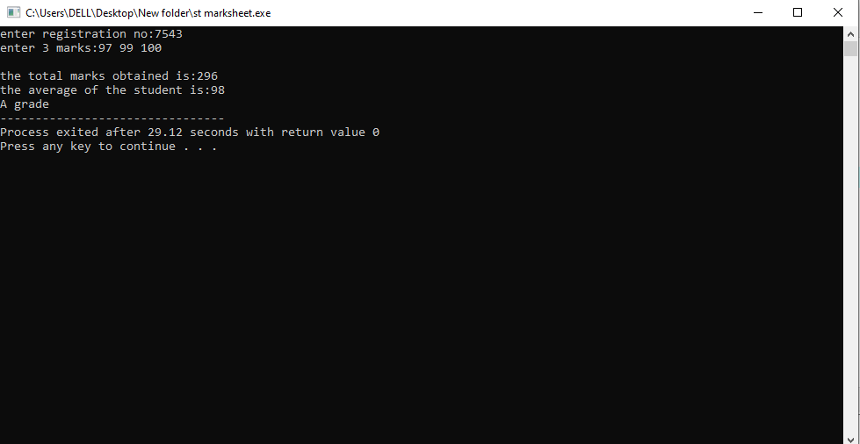

1. WAP in C++ to print the full pyramid pattern

PROGRAM-

#include <iostream>

using namespace std;

int main()

{

int space, rows;

cout <<"Enter number of rows: ";

cin >> rows;

for(int i=1,k=0;i<=rows;++i,k=0)

{

for(space=1; space <= rows-i; ++space)

{

cout <<" ";

}

while(k != 2*i-1)

{

cout << "* ";

++k;

}

cout << endl;

}

return 0;

}

OUTPUT-

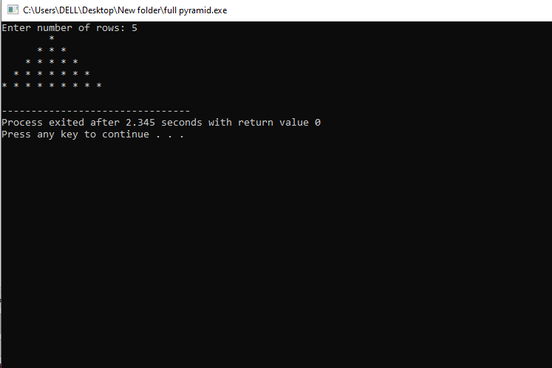

1. WAP in C++ to print full pyramid using numbers

PROGRAM-

#include <iostream>

using namespace std;

int main()

{

int rows, count = 0, count1 = 0, k = 0;

cout << "Enter number of rows: ";

cin >> rows;

for(int i = 1; i <= rows; ++i)

{

for(int space = 1; space <= rows-i; ++space)

{

cout << " ";

++count;

}

while(k != 2*i-1)

{

if (count <= rows-1)

{

cout << i+k << " ";

++count;

}

else

{

++count1;

cout << i+k-2*count1 << " ";

}

++k;

}

count1 = count = k = 0;

cout << endl;

}

return 0;

}

OUTPUT-

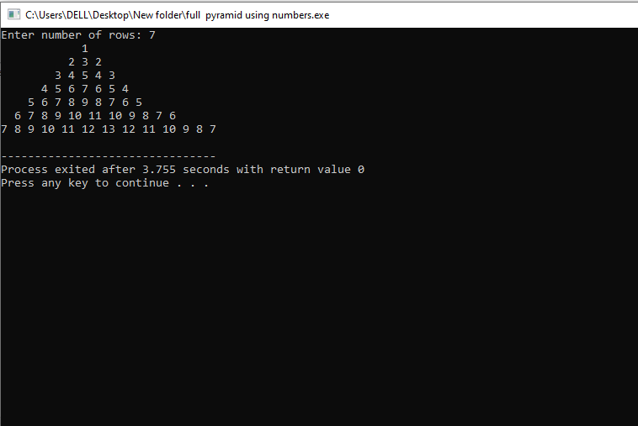

1. WAP in C++ to print half pyramid pattern

PROGRAM-

#include <iostream>

using namespace std;

int main()

{

int n,i,j;

cout<<"enter the no. of rows:";

cin>>n;

for(i=1;i<=n;i++)

{

for(j=1;j<=i;j++)

{

cout<<"* ";

}

cout<<"\n";

}

return 0;

}

OUTPUT-

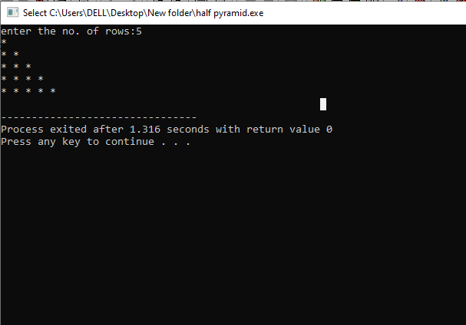

1. WAP in C++ to print inverted half pyramid pattern

PROGRAM-

#include <iostream>

using namespace std;

int main()

{

int rows,i,j;

cout<<"enter theo. of rows:";

cin>>rows;

for(i=rows;i>=1;--i)

{

for(j=1;j<=i;++j)

{

cout<<"* ";

}

cout<<"\n";

}

return 0;

}

OUTPUT-

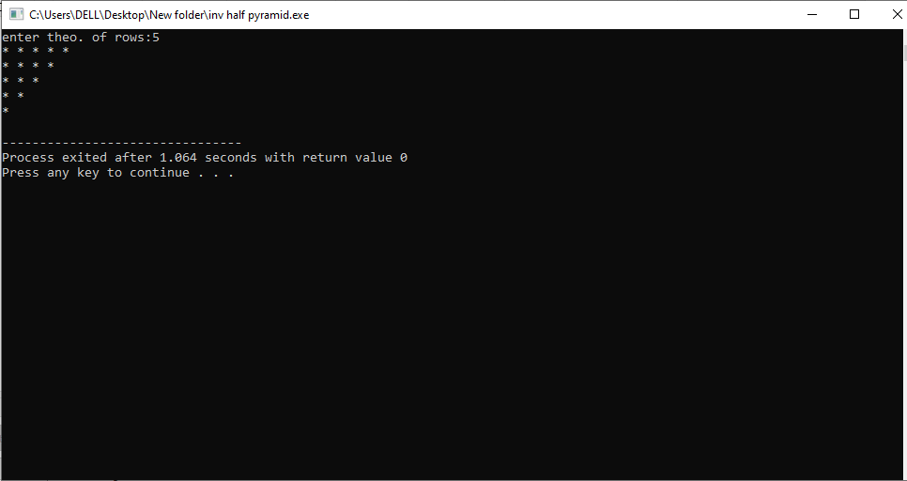

1. WAP in C++ to print the half pyramid of Alphabets

PROGRAM-

#include <iostream>

using namespace std;

int main()

{

char input,alphabet='A';

cout<<"enter the uppercse character:";

cin>>input;

for(int i=1;i<=(input-'A'+1);++i)

{

for(int j=1;j<=i;++j)

{

cout<<alphabet<<" ";

}

++alphabet;

cout<<endl;

}

return 0;

}

OUTPUT-

